Welcome to your ProctorExam guide!
Exams can be nerve-wracking and perhaps online exams are new for you. But this guide will help you to seamlessly get through your exam.
Here are some quick links to help you prepare for your online exam.
- Click here to watch an introduction about taking an exam remotely using ProctorExam. Please note that your exam might be excluding the mobile phone.
- Read on pages 2 to 5 more on the steps of the process you will need to take
- Read on ProctorExam website:
  - what you will need to have to start your exam
  - how you should set your room
  - what you should avoid
- Make sure to have Google Chrome set up on your computer and add the ProctorExam extension which is required to share your screen.
5. ProctorExam is contracted by your institution to facilitate your examination. We have strict commitments to the respect of your privacy. You can find our privacy statement here.
6. If you need technical help before or during the exam, use the chat window at the bottom right of your screen to speak to an agent. We don’t use any chatbots, you’ll always find a human being to talk to!

Steps of the ProctorExam process
To access your exam, you will need to follow the steps outlined below:
Email 1: Check your equipment
This is the first e-mail you will receive, with the object: “Please register for your exam”. Please also check your spam folder for this e-mail.
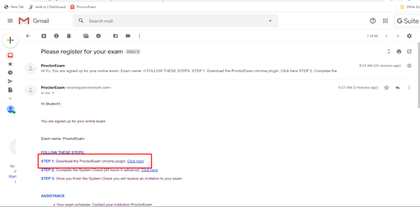
Step 1: Install the ProctorExam Chrome plug-in as directed.
Step 2: Proceed to the System Check. You will be re-directed to a page in your Google Chrome browser as below. Keep following the instructions on the screen until you complete the System Check successfully.
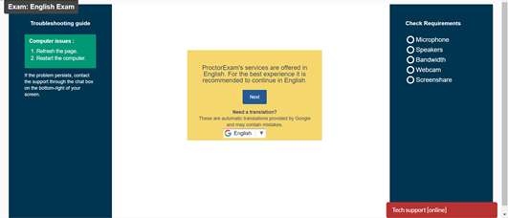

Email 2: Receiving the link to start your exam
Upon successful completion of the system check, you will receive a second email with the link to your exam, such as the image below:
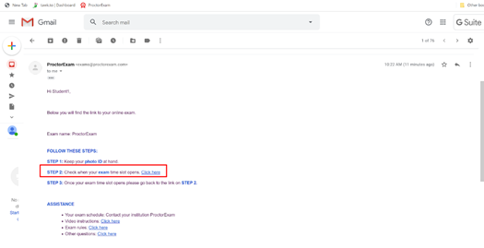
Click on Step 2 and don’t forget to have your ID with you for verification. You will be re-directed in your Google Chrome browser to a screen like this:
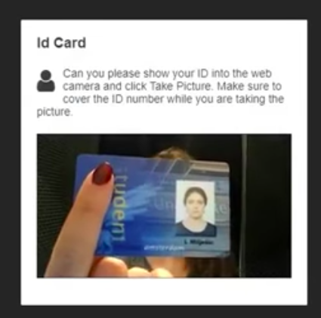
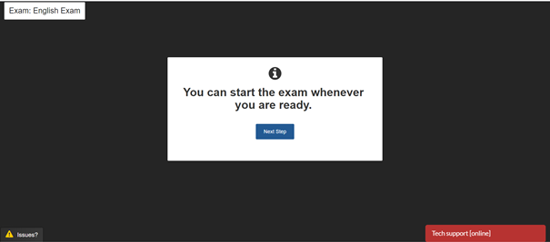

Keep following the instructions on the screen until you enter your exam.
Each step of the process has a little video which shows you exactly what do, so it is easy to follow.

